Techno-Science Research Journal 3 (2013) 24-32

Content list available at ITC



Techno-Science Research Journal

Journal Homepage : [www.itc.edu.kh](http://www.itc.edu.kh/)

**Simulation and Prediction of Land Use Change in Chrey Bak River Catchment, Kampong Chhnang Province**

Chhaly Svay*, Sarann Ly

*Department of Rural Engineering, Institute of Technology of Cambodia, Russian Ferderation Blvd., P.O. Box 86, Phnom Penh, Cambodia.*

**Abstract:** *Chrey Bak River catchment is recognized by the Royal Government of Cambodia (RGC) as an important area for agricultural investment and development. As a consequence, the catchment has experienced intensive land use and land cover changes. The objectives of this paper are to investigate the land use change in Chrey Bak River catchment during 2010-2040 and to define the underlying factors/decision variables that affect to land use change and to use CLUMondo model for the simulation and predicton. Data of initial land use map (2010) and trend data of the change in land use of Cambodia (2004-2013) with Annual Growth Rate method were used to project the areas of each land use type until 2020. The results of the simulation indicate that during the period of 2010-2040, water bodies still remain constant with an area of 27 ha while built-up areas would be expanded by 142% (from 251 ha to 608 ha). In addition, grasslands and shrublands areas would be increased respectively by 7% (from 4151 ha to 4430 ha) and by 8% (from 25254 ha to 27240 ha). Furthermore, the agricultural expansion would happens significantly in the study area and it would be grown up by 19% (from 25763 ha to 30738 ha). In contrast, there would be a rapid decline in Forest covers by 47% (from 16083 ha to 8486 ha). This study also provides a model validation method named “Kappa Statistics” which is very practical for land use change comparison. On the basis of the results of this research, it can be concluded that land use change prediction of Chrey Bak River catchment by using CLUMondo model can suitably serve as an indicator of the direction and magnitude of change in the future. Land use change modeling is now highly dynamic field of research with many new developments and the results of land use models are important to evaluate policy options and assess the impact of land use change on natural and socio-economic conditions.*

**Keywords:** Land use change; Drivers; CLUMondo model; Annual growth rate method; Chrey Bak River catchment

## INTRODUCTION

Across Southeast Asia, land cover/use change is increasing with population growth and the shift from subsistence-oriented to market-based agriculture. In Cambodia, land use and land cover (LULC) are changing rapidly, particularly as a result of commercial forestry, agricultural expansion and infrastructure development such as irrigation reservoirs and networks. Both the quality and quantity of water resources in Cambodia are linked to the characteristics of land cover and patterns of land use. Land use/cover change has become an event being of paramount importance to the study of global environmental change (Liu et al., 2003). In broad terms, the process of land use change is determined by universal driving forces such as population increase, urbanization, industrialization, and so on (Morita et al., 1997). On the other hand, it also depends on local characteristics such as inherent socio-economic and natural conditions and behavioral characteristics of the people. To develop effective policy recommendations, land use change

* Coresponding author:

models that are sensitive to local characteristics are needed for scenario evaluation.

Land use change is a complex, dynamic process that links together natural and human systems. It has direct impacts on

soil, water and atmosphere (Meyer and Turner, 1994) and is

thus directly related to many environmental issues of global importance. The large-scale deforestations and subsequent transformations of agricultural land in the tropics are examples of land use change with strong likely impacts on biodiversity, soil degradation and the earth’s ability to support human needs (Lambin et al., 2003). Land use change is also one of the important factors in the climate change cycle and the relationship between the two is interdependent; change in land use may affect the climate while climate change will also influence future land use (Dale, 1997; Watson et al., 2000). On a smaller scale, in the densely populated parts of the urbanized western world, land use change is the expression of continuing urbanization pressure on ever scarcer open spaces

(e.g. Bell and Irwin, 2002; Rietveld and Wagtendonk, 2004), many of which have been designated by planning authorities

1. *mail: svaychhaly@gmail.com; Tel: +855-89-246-014*

as greenfield areas for conservation reasons. This issue is often referred to as urban sprawl, a topic of debate in the United States especially (e.g. Brueckner, 2000; Glaeser and Kahn, 2004). Modelling of land use change helps understand the processes of continuing urbanization and can also be of value in informing policymakers of possible future conditions under different scenarios. Land use change models can therefore be defined as tools to support the analysis of the causes and consequences of land use change (Verburg et al., 2004). Many authors (e.g. Lambin et al., 2001) make a distinction between the land cover that can be observed (e.g. grass, building) and the land use, the actual use to which the land is put (e.g. grassland for livestock grazing, residential area). For convenience, we use the term land use predominantly in this paper, referring to both land cover and actual land use.

General objective is to study and understand a methodological framework for a systematic study of land use modeling for predicting the land use change over Chrey Bak

River catchment for period 2010 to 2040. Specific objectives

of this study are:

* + To identify the land use change in Chrey Bak River catchment
  + To define the underlying factors/decision variables for land use change
  + To predict land use change in the catchment until 2040. This study intended to integrate together GIS (ArcMap)

and CLUMondo model approach to detect change in land use

pattern of Chrey Bak River catchment. The model could help to visualize future land use scenarios of this catchment as well as areas around Asia. Thus, other biogeographical features and demographic and socio-economic factors could be integrated to study their impacts on decision process of people to change the land use. The present land use map for this study area was prepared and classified into 6 categories of land use including Grasslands, Agricultural lands, Shrublands, Forest covers, Water features, Urban/Built-up areas.

## METHODOLOGY

* 1. *Study area*

The proposed study area is conducted in Chrey Bak River catchment (Figure 1), located southwest of the provincial capital of Kampong Chhnang province, one of the six provinces surrounding the Tonle Sap Lake. It is also a sub- catchment of the Tonle Sap basin. Chrey Bak River catchment is recognized by the Royal Government of Cambodia (RGC) as an important area for agricultural investment and development. It is made up of 18 communes including Krang Skear, Srae Thmei, Kampong Chhnang, Krang Leav, Chrey Bak, Kouk Banteay, Andoung Snay, Rolea B’ier, Prey Mul, Tang Krasang, Cheung Kreav, Chieb, Khlong Popok,

Trapeang Chour, Akphivoadth, Chaong Maong, Tuol Khpos, and Kbal Tuek. A range of stakeholders have invested in land and water resource “development” in Chrey Bak River, including local farmers, donors, national and local government agencies and business

communities. Agricultural production, in particular paddy rice production, has had significant expansion and intensification. As a consequence, the catchment has experienced intensive land use and land cover (LULC) change, particularly in the last 20 years (Chann et al. 2011). The total land area of the catchment is approximately 715.29 km2 with the total population about 45,149 people (analyzed from ODC Census data 2008).

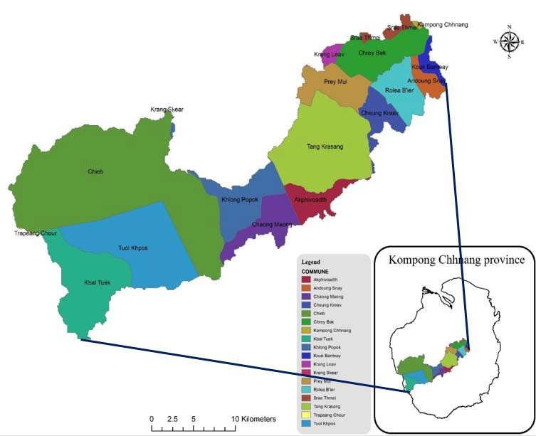

Fig.1. Location map of Chrey Bak River catchment, Kampong Chhnang province, Cambodia

* 1. *ethodology*

To do land use change simulation of the study area, the flowchart below (Figure 2) should be followed step by step and the main things to be prepared of this study is to deal very well with ArcMap, CLUMondo model, and understand about land use change processes in the real world.

|  |  |
| --- | --- |
|  | - Swidden agriculture  (Slash and burn) |
| 2-Shrublands | * Shrubland (undifferentiated) * Abandoned field covered by shrub * Woodland and scattered   trees (C<10%) |
| 3-Forest covers | * Deciduous forest * Bamboo and Secondary forests * Dry Deciduous (Open) forest * Evergreen broad leafed   forest   * Mixed forest from evergreen and deciduous species |
| 4-Water features | * Lakes (< 8 ha) * Lakes (> 8 ha) * Others (Sea, Bay etc.) |
| 5-Urban, Built-up areas | - Settlement |

Fig.2. Methodology flowchart of the case study area

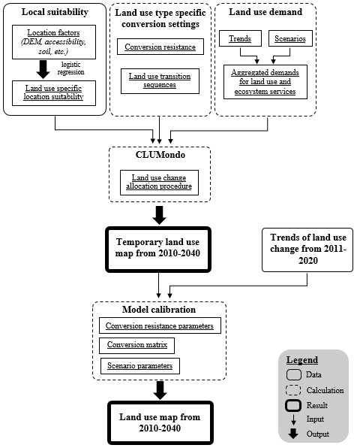

* 1. *Data collection*
     1. *Land use map*

The main data that need to be collected are the initial land use map and the region map of the study area (Figure 3) and it is collected from Department of Rural Engineering. These two main data will also be asked for first to input in CLUMondo model. However, the initial land use map in 2010 is taken as the start year of simulation. In the land use map, 6 categories of land use were found (Table 1) and the areas covered by each land use type are also presented (Table 2).

Table 1. Land use classification system

Table 2. Area in different land use types of initial land use of Chrey Bak River catchment

Land use types Area in the year of 2010 (hectare)

Grasslands 4151

Agricultural lands 25763

Shrublands 25254

Forest covers 16083

Water features 27

Urban,Built-upareas 251

Fig.3. Initial land use map for Chrey Bak River catchment case study

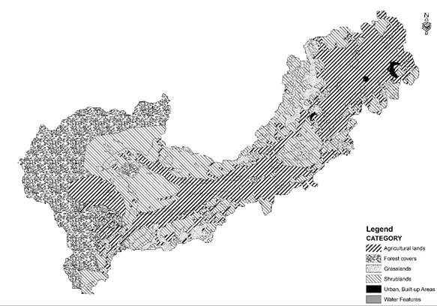

|  |  |
| --- | --- |
| Categories used for  modeling | Categories in the original  data |
| 0-Grasslands | * Abandoned field covered   by grass   * Grassland (undifferentiated) |
| 1-Agricultural lands | * Paddy field * Garden crop * Village garden crop * Field crop |

* + 1. *Driving factors of change*

After the initial land use and region map are collected, its driving factors that will be included in “Suitability layers” of CLUMondo user interface need to be found (Table 3) and input in the model. These driving factors indicate the factors that can affect land use change. In this paper, 5 data of driving factor for the study area are collected including DEM, slope, accessibility to health center, population density , and soil fertility and it’s also classified into 2 types.

Table 3. Driving factors of change in the study area

|  |  |
| --- | --- |
| Data | Driving factors |
| Biophysical | Elevation  Soil fertility Slope |
| Socioeconomic | Accessibility to health center Population density |

* + 1. *Land use data creation of Chrey Bak River catchment from 2011-2020*

In fact, the exact data of land use of the catchment after 2010 could not be provided to do this simulation, so we decided to consider numerical data that have been uploaded by a website: [http://knoema.com/atlas/Cambodia,](http://knoema.com/atlas/Cambodia) because it will reach to find reliable land use data for the study area in the year preferred (Table 4). These data contain only for the changes of 3 land use types of Cambodia such as agricultural area, forest area, and urban area from 2004 until 2013.

Table 4. Data of land use change of Cambodia 2004-2013

|  |  |  |  |
| --- | --- | --- | --- |
| Year | Agricultural area  (ha) | Forest area  (ha) | Built-up area  (ha) |
| 2004 | 5230000 | 10894000 | 1528000 |
| 2005 | 5356000 | 10731000 | 1565000 |
| 2006 | 5455000 | 10604000 | 1593000 |
| 2007 | 5455000 | 10476000 | 1721000 |
| 2008 | 5555000 | 10349000 | 1748000 |
| 2009 | 5555000 | 10221000 | 1876000 |
| 2010 | 5655000 | 10094000 | 1903000 |
| 2011 | 5655000 | 9967000 | 2030000 |
| 2012 | 5755000 | 9839000 | 2058000 |
| 2013 | 5800000 | 9712000 | 2140000 |

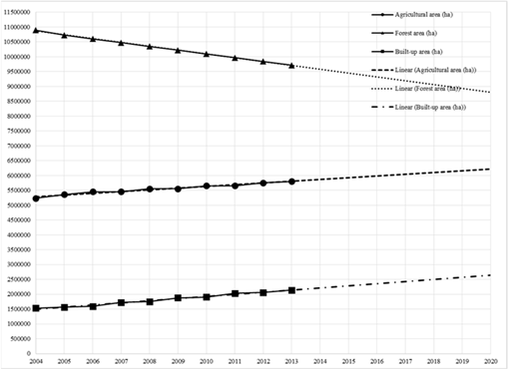

Fig.4. Trends of land use change of Cambodia from 2004- 2020

According to the linear trends in the graph, annual growth rate of the three land use types can be calculated by using Annual Growth Rate method (Equation 1):

F = P(1+i)N or i = (F/P)1/N - 1 (Eq. 1)

where:

F = future land area of a land use type (ha)

P = present land area of a land use type (ha)

i = annual growth rate of a land use type (%)

N = number of year between present and future land uses

Thus the calculation of annual growth rate of land use types in Cambodia can be done as follow:

|  |  |  |  |
| --- | --- | --- | --- |
| Year | Agricultural  area (ha) | Forest area  (ha) | Built-up  area (ha) |
| 2004 | P = 5250000 | P = 10850000 | P =  1490000 |
| 2020 | F = 6240000 | F = 8800000 | F = 2650000 |
| N = 16 | i = 0.0109 | i = -0.0130 | i = 0.0366 |
| = 1.09 % | = -1.30 % | = 3.66 % |
| (Increase) | (Decrease) | (Increase) |

The trends of land use change of Cambodia from 2004 to 2020 can be viewed by plotting data above and using linear trend line to do projection until 2020 (Figure 4).

Assuming that the change of land use of Chrey Bak River catchment suffers annual growth rate as the same as Cambodia do. Thus, land use data for Agricultural area, Forest area, and Built-up area of Chrey Bak River catchment from 2010 to 2020 will be found (Table 5) and reasonable for modeling land use.

Table 5. Expected changes in area for some land use types of Chrey Bak River catchment 2010-2020

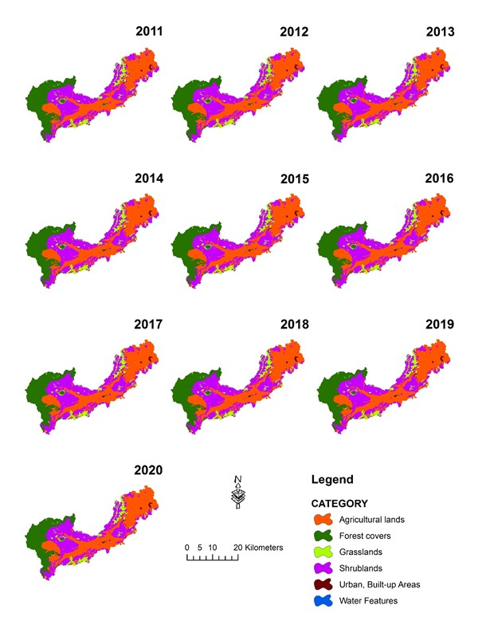

Year

Agricultural area (ha)

i = 1.09 %

Forest area (ha)

i = -1.30 %

Built-up area (ha)

i = 3.66 %

2010 P = 25763.00 P = 16083.00 P = 251.00

2011 26043.82 15873.92 260.19

2012 26327.69 15667.56 269.71

2013 26614.67 15463.88 279.58

2014 26904.77 15262.85 289.81

2015 27198.03 15064.43 300.42

2016 27494.49 14868.60 311.42

2017 27794.18 14675.30 322.81

2018 28097.13 14484.53 334.63

2019 28403.39 14296.23 346.88

2020 28712.99 14110.38 359.57

The data of the three land use types above allow us to create land use map of the study area in 10 different years (2011-2020) (Figure 5) using ArcMap and basing on initial land use map in 2010 to adjust each land use area for 10 other land use maps. But there are 6 categories of land use in the study area and one thing to remember is that one type of land use (Water features) remains constant in every year of the simulation period. So, there are only two types of land use (Grasslands and Shrublands) that will be changed unconditionally during creating those maps and these problems won’t cause much error for modeling.

Fig.5. Created land use maps from 2011-2020

These maps will be used to validate the model with other ten simulated land use maps from the model in the section “3.2 Model validation”.

* + 1. *Scenario parameters*

The final stage of the model parameter preparation are the scenario parameters. The first step is to calculate the services that are provided in the initial land use map. This depends on the values that you have identified for the ‘Land use Services’, and the number of cells in each class in the initial map. In this paper it is suggested 1 hectare of built-up land per cell of urban. In the initial land use map (see Table 2), there are 251 cells with urban land. Hence, in total there are 1 ha/cell × 251 cell = 251 ha of built-up land. Similarly, it also can be calculated the Staple food production in 2010, which is suggested 2.16 tons of staple crop production per cell of Shrublands, and 0.02 tons of staple crop production per cell of Forest covers. In the initial land use map, there are 25254 cells with Shrublands and 16083 cells with Forest covers. Hence, in total there are (2.16 tons/cell × 25254 cell) + (0.02 tons/cell × 16083 cell) = 54867 tons or 54870 tons of built-up land. Do the same for Arable cash crop and Tree cash crop production, it will obtain respectively 1.34 tons/cell × 25763 cell = 34522 tons and 3.18 tons/cell × 4151 cell = 13200 tons.

Remark:

* + - * The number of cells in the initial land use map can be derived relatively easily in the MCK.
      * Urban area, Staple crop production, Arable cash crop production, and Tree cash crop production are estimated

to increase their quantities respectively, 3%, 0.25%,

0.60%, and 0.25% per year from 2010 to 2040.

* + 1. *Model calibration*

CLUMondo has a number of parameters that need to be specified before a final simulation can be made. The setting of these parameters is dependent on the assumptions related to a particular scenario. You can define different scenarios by adjusting the following model parameters:

* + - * Conversion resistance parameters
      * Conversion matrix
      * Scenario parameters

The values of these parameters can be adjusted based on an analysis of the land use system and expert opinion in the study area until there are similar trends with quantity and

location of each land use type for the study area by modifying

between the simulated map and the map created from ArcMap in (Figure 5).

## RESULTS AND DISCUSSION

* 1. *esults*

After the run of simulation is completed, all output files are saved in the same directory where the CLUMONDO model is installed. Besides the log-file files are created during the simulation. First, for each year a file cov_all.* is created (Figure 6), where * stands for the year of the simulation. It contains the resulting land use type distribution after the simulation for 2010-2040. This is an ASCII file that can be imported by a GIS package (ArcGIS, IDRISI, QGIS).

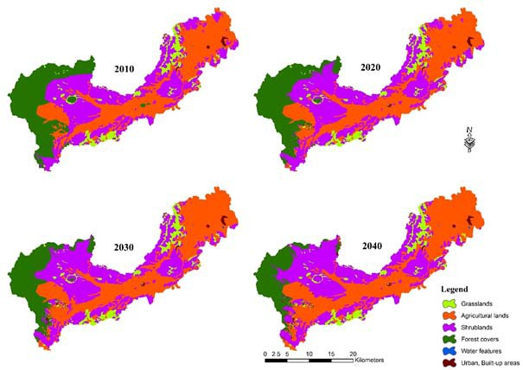

Fig.6. Modeled land use maps from 2010-2040

Moreover, the model will produce a file called “landarea.txt” in the directory. The file contains the information on areas allocated in each year of the different land use systems (in terms of number of cell).

To help analyzing the results, it is also possible to open the “landarea.txt” file in Microsoft Excel. The following table (Table 6) indicates only land use areas of different land use types for 2010, 2020, 2030, and 2040. Moreover, this output also can be generated to a graph (Figure 8) representing the change of each land use type over that period.

Table 6. modeled land use areas in hectares (2010-2040) of different land use types

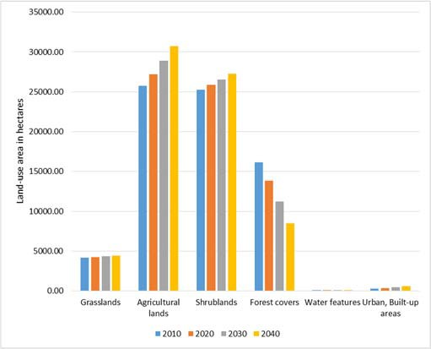

|  |  |  |  |  |
| --- | --- | --- | --- | --- |
| Year | 2010 | 2020 | 2030 | 2040 |
| Grasslands | 4151 | 4237 | 4339 | 4430 |
| Agricultural lands | 25763 | 27222 | 28923 | 30738 |
| Shrublands | 25254 | 25838 | 26517 | 27240 |
| Forest covers | 16083 | 13866 | 11267 | 8486 |
| Water features | 27 | 27 | 27 | 27 |
| Urban, Built-up areas | 251 | 339 | 456 | 608 |

Fig.8. Graph indicating the change in land use from 2010- 2040

* 1. *Model validation*

In general, a series of aerial photographs or satellite images is always taken to prepare a land use map of different dates (years). But for this study, due to limited time of the research and limited knowledge I decided to use numerical data of land use trends for Cambodia from a website of [http://knoema.com/atlas/Cambodia,](http://knoema.com/atlas/Cambodia) to consider as the land use trends for the study area (for the details, see section 2.3.3).

To allow model validation, it is required to have at least 10 land use maps (observed land use maps) in different year after the initial year to compare with the modeled land use

maps and also it is recommended to perform MCK by using “Kappa Statistics” method (Equation 2).

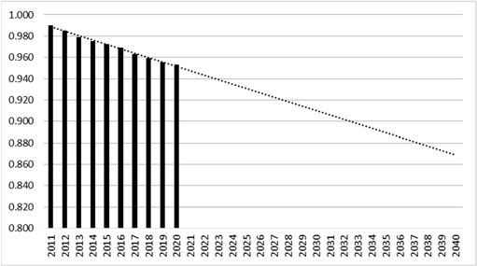

Kappa = KHisto × KLocation (Eq. 2)

where:

KHisto = similarity of quantity between the two compared maps

KLocation = similarity between the two maps in terms of location

Values of Kappa closer or equal to 1, mean that the two

maps are more similar either in terms of quantity or location. The calculation of each Kappa value is done automatically by MCK (Table 7).

* 1. *Discussion*

Fig.10. Projected Kappa values

Table 7. Summary of Kappa Statistics for the model validation

|  |  |  |  |
| --- | --- | --- | --- |
| Kappa Indices  Year | Kappa | KLocation | KHisto |
| 2011 | 0.990 | 0.994 | 0.996 |
| 2012 | 0.985 | 0.991 | 0.994 |
| 2013 | 0.979 | 0.991 | 0.988 |
| 2014 | 0.975 | 0.989 | 0.985 |
| 2015 | 0.972 | 0.988 | 0.984 |
| 2016 | 0.969 | 0.989 | 0.980 |
| 2017 | 0.963 | 0.986 | 0.976 |
| 2018 | 0.959 | 0.986 | 0.972 |
| 2019 | 0.955 | 0.986 | 0.969 |
| 2020 | 0.953 | 0.989 | 0.964 |

Pontius (2000, 2002) tried to prove that standard Kappa is not giving proper information. However, that concept has not yet been recognized globally by the international scientists. The land use modelers extensively use Kappa, as a simple index to evaluate the accuracy of base maps and for map comparison purposes. Therefore, still Kappa is a very popular and well recognized map comparison index.

After analyzing of all Kappa values in Table 7, it can be concluded that CLUMondo is showing the high values of Kappa coefficients (greater than the minimum standard of

0.850 stipulated by the USGS classification scheme) for every

year of validation period. The assumption is like—the higher the Kappa values, the better the simulation.

Furthermore, the projected Kappa values until the end of the simulation period is still greater than the minimum standard of 0.850 which can be indicated in (Figure 10).

Land use change is a major driver of change in the spatial pattern and overall provision of ecosystem services. This thesis describes how GIS, CLUMondo model, and Statistics are combined to address land use changes in Chrey Bak River catchment during period of 2010-2040. The CLUMondo model simulation projected that “Water features” area would remain constant for an area of 27 hectares during the period of 2010-2040 while “Built-up” areas would be increased by 142% (from 251 hectares to 608 hectares). In addition, “Grasslands” and “Shrublands” areas would be expanded respectively by 6.7% (from 4151 hectares to 4430 hectares) and by 7.9% (from 25254 hectares to 27240 hectares) for the same period. Similarly, agricultural expansion would happen significantly in the study area and it would be grown up by 19% (from 25763 hectares to 30738 hectares). As a consequence, it would have a rapid decline in “Forest covers” area by 47% (from 16083 hectares and 8486 hectares).

As can be seen (Figure 8), all the changes of each land use type are almost linear except the type of water features that

remain stable. The main reason that produces the results

performing like this is that all data of scenario parameters including built-up area, staple crop production, arable cash crop production, and tree cash crop production; were defined annually by a linear increase form.

During 2010 to 2015, high agricultural prices generated high returns to agriculture relative to returns to other land uses, driving land out of forest and grassland and into agricultural land and urban land. The shift toward agricultural land increases the amount of staple crop production and generates a medium arable cash crop production in that region.

However, this simulated results are mostly obtained by the main drivers of change selected including the data of accessibility to health center, elevation, slope, population

density, and soil fertility of the study area. There are also other

important data such as scenario parameter data such as the demand of built-up area, staple crop production, arable cash crop production, and tree cash crop production; and the data of land use services in the study area. Although our analyses

address several of the main forces that drive land use change and their impacts on ecosystem services, there are additional aspects of these relationships that our models do not address. For example, we do not include analyses of changes in land management. Land management is likely to respond to changes in relative prices and to biophysical restrictions. We would, for instance, expect more intensive farming practices in response to higher agricultural prices. Our conclusions regarding trends in wildlife habitat are also a function of the species we have chosen to evaluate and not just patterns in land use change. For example, few of these species we have modeled are threatened or endangered. These somewhat common species generally have relatively large ranges and are less likely to experience large percentage changes in habitat area than are more area-restricted species. Also, although climate change could affect certain scenarios and policies more than others we will leave that analysis for further research.

## CONCLUSIONS

For the period of 2010-2040, many part of forest covers with the low elevation would be generated to other land use types such as grasslands, shrublands, and specially the agricultural lands. However, expansion of built-up areas would happen in all their surrounding areas excluding the type of water features. After analyzing the results and doing model validation, land use change simulation of Chrey Bak River catchment by using CLUMondo model can suitably serve as an indicator of the direction and magnitude of change in the future. In that, driving factors of change such as biophysical and socio-economic factors mentioned in the previous section truly lead to drive the change in land use over this catchment. The prediction of land use change for the future becomes an important topic that can pioneer advanced research about global environmental change. Consequently, land use change modeling is now highly dynamic field of research with many new developments and the results of land use models are important to evaluate policy options and assess the impact of land use change on natural and socio-economic conditions.

The recommendations of this study are to use Landsat TM data and classify each land use types by using image classification techniques even it takes much time and requires

advanced knowledge with software systems. Moreover, it is

recommended to select a study area like a provincial area or a country area better than a small catchment because in some cases, a land use type like forest cover would cover most part of the catchment and then the simulation would not provide a good result.

## ACKNOWLEDGMENTS

It is our great pleasure to convey our deepest gratefulness to MOWRAM-ADB for granting scholarship to Mr. Svay Chhaly to complete his bachelor’s study at ITC. Furthermore, we deeply thank Dr. Heng Sokchhay, lecturer and researcher of ITC, for his encouragement, guidance and many valuable comments on various drafts of this paper.

## REFERENCES

Bella, K. P., & Irwin, E. G. (2002). Spatially explicit micro- level modelling of land use change at the rural–urban interface. Agricultural Economics, 27: 217-232.

Brueckner, J. K. (2000). Urban sprawl: diagnosis and remedies. International Regional Science Review, 23(2), 160-171.

Chann, S., Wales, N., & Frewer, T. (2011). An investigation of land cover and land use change in Stung Chrey Bak catchment, Cambodia. CDRI.

Dale, V. H. (1997). The relationship between land-use change and climate change. Ecological Applications, 7: 753-769. Glaeser, E. L., & Kahn, M. E. (2004). Sprawl and urban growth. Handbook of Regional and Urban Economics, 4:

2481-2527.

Knoema (2013). Cambodia Land Use Data and Statistics.

Retrieved on 03 March 2016 from https://knoema.com/atlas/Cambodia.

Lambin, E.F., Geist, H.J. and Lepers, E. (2003). Dynamics of

land use and Lland-cover change in tropical regions. Annual Review of Environment and Resources, 28: 205– 241.

Lambin, E.F., Turner, B.L., Geist, H.J., Agbola, S.B.,

Angelsen, A., Bruce, J.W., Coomes, O.T., Dirzo, R., Fischer, G., Folke, C., George, P.S., Homewood, K., Imbernon, J., Leemans, R., Li, X., Moran, E.F., Mortimore, M., Ramakrishnan, P.S., Richards, J.F., Skanes, H., Stone, G.D., Svedin, U., Veldkamp, T.A., Vogel, C. and Xu, J. (2001). The Causes of land use and land-cover change, Moving Beyond The Myths. Global Environmental Change, 11: 261–269.

Liu, J., Liu, M., Zhuang, D., Zhang, Z., & Deng, X. (2003).

Study on spatial pattern of land use change in China during 1995-2000. Science in China Series D: Earth Sciences, 46: 373-384.

Meyer, W.B. and Turner, B.L. (1994). Changes in land use and land cover. Cambridge University Press.

Morita, H., Hoshino, S., Kagatsume, M., & Mizuno, K. (1997). An application of the land use change model for the Japan case study area. IIASA Interim Report IR-97- 065.

Rietveld, P., & Wagtendonk, A. J. (2004). The location of new residential areas and the preservation of open space: experiences in the Netherlands. Environment and Planning A, 36: 2047-2063.

Verburg, P. H., Schot, P. P., Dijst, M. J., & Veldkamp, A. (2004). Land use change modelling: current practice and research priorities. GeoJournal, 61: 309-324.

Watson, R.T., Noble, I.R., Bolin, B., Ravindranath, N.H., Verardo, D.J. and Dokken, D.J. (2000). Land use, land use change, and forestry. Cambridge University Press.